User Manual
Didactor: Pro-Active Mail Component

Submitted to
Mediator Group

By


Document Management

Document History

Version | Description | Datum | Author
0.8 | Draft | 18.10.2006. | Goran Kostadinov

References

Source | Datum | Author
Didactor Pro-active Mail Functional Design, ver. 0.1 | 02.05.2006 | Radomir Mladenovic

Contact Persons
Milan Sretic, Levi9, milan@levi9.com

Table of Contents

User Manual 1
Document Management 2
Table of Contents 3
1 Introduction 4
2 Installing 5
2.1 Getting Pro-Active Mail 5
2.2 Requirements 5
2.3 Library Dependencies 5
3 Using Pro-Active Mail 6
3.1 How it works 6
3.2 Running component 7
3.3 Setting component 8
3.3.1 Setting email template types 8
3.3.2 Setting email template context 8
3.3.3 Setting email scheduler 9
3.3.4 Setting script 10
3.3.4.1 Collect users 10
3.3.4.2 Filtering users 11
3.3.4.3 Sending emails 12
3.4 Testing new script 13
4 Permissions 14
5 Delivered context 15
6 Complete simple example 16

Introduction
Pro-Active Mail component, introduced in Didactor 2.2 release, has simple purpose: to make possible emailing the Didactor users about some events, for example that user did not visit the training for longer than one month.

This purpose is accomplished with well defined task for system administrator:
- Defining email context (template), group of Didactor users who should be emailed and send time, using well known Didactors edit-wizard functionality;
and for teacher:
- changing the email context and group of Didactor users who should be emailed.

Pro-active emailing is provided via script and can be easy customized according to Didactor Provider’s needs, without significant effort. This is accomplished with a general purpose scripting framework and job scheduler for script triggering.

Installing

Getting Pro-Active Mail
Pro-Active Mail component is part of Didactor since version 2.2, and is delivered to providers according to their need. No special installing procedure for this component is needed.

Requirements
To use Pro-Active Mail component, EMail Didactor component must be installed and available to providers.

Library Dependencies

Pro-Active Mail component depends of the following libraries:
Jar name | Needed for | Available at
js.jar | server-side java script executing | - Didactor distribution that include Pro-Active Mail component  - http://www.mozilla.org/rhino/download.html
quartz-1.5.2.jar | job scheduling | - Didactor distribution that include Pro-Active Mail component  - http://www.opensymphony.com/quartz/download.action

Using Pro-Active Mail

How it works
Component is based on four types of templates:
- Email type template - define
the name of rule for sending emails to Didactor users, for example: MonthAfterRegistration template type, or TwoMontsNoLogin template type;
- Email context template - define
- context of email:
  - subject, body, from part;
- group of user email should be sent, grouped by:
- provider, education, class, role or people;
- optional date email should be sent;
- email type.
- Scheduler template - define
the exact time when script template will be called.
- Script template – define
users who will be emailed (final filtering) and do sending email.

So, symbolicly speaking, when scheduler time come, it call script which is related to it, script call email context template related to it to collect all users who should be emailed, do final filtering of users and send email to them. Sequence diagram is shown on figure 1.
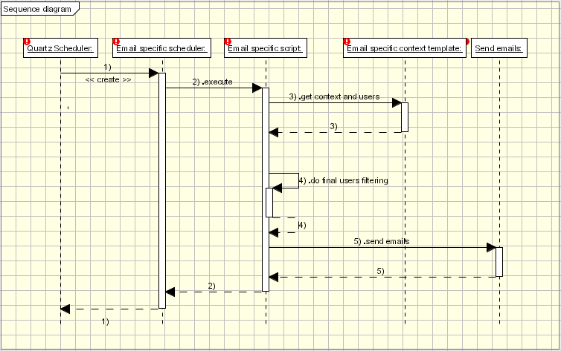
1. Sequence diagram

Running component
To run the component, system administrator must activate it, using Didactor coursemanagement - components functionality, and activate it for desired providers. Example is shown on the figure 2.

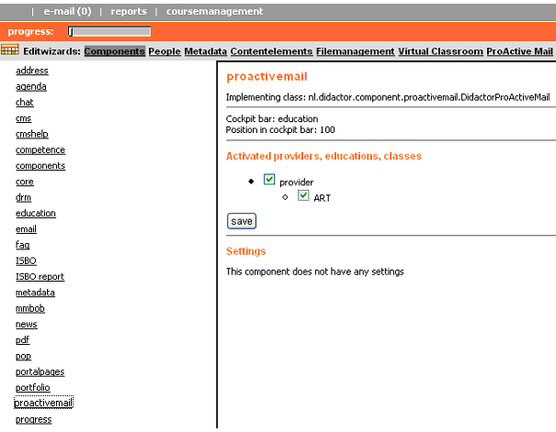
2. Activating component

Setting component
Component can be set by systemadministrator, using “ProActive Mail” link in coursemanagement, figure 3.

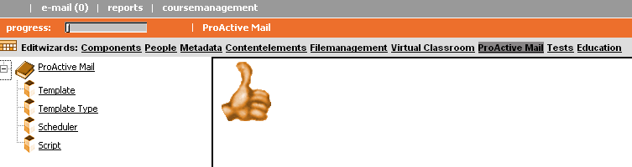
3. Setting component

    - Setting email template types

First step to define new type of emailing the users is to made new template type, figure 4.

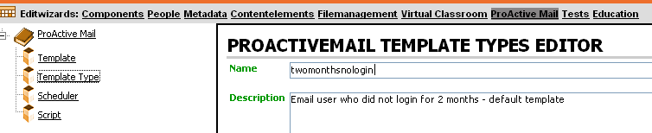
- Defining new template type

Setting email template context

Second step is to define email context template, figure 5.
In this step system administrator defines the name of template, subject and body of email, from field of email, is this email template active, template type, optional date when email should be sent, and groups of user that should be emailed, grouped by providers and/or education and/or classes and/or people and/or roles of user.

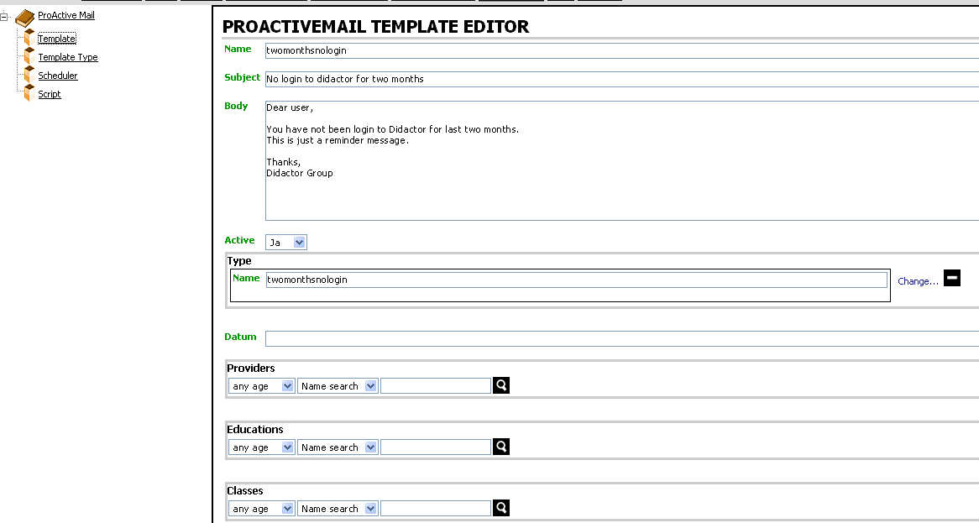
- Defining new email context template

    - Setting email scheduler

Third step is to define scheduler template, figure 6.

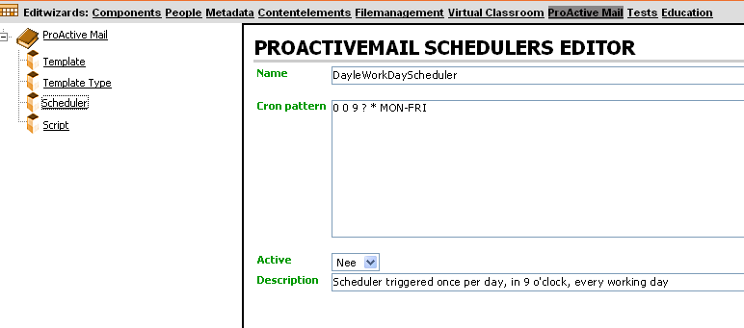
- Defining new scheduler template

In this step, system administrator defines the new scheduler. The most important field are date and time when scheduler should be run. Date and time are defined using field cron pattern, which syntax can be seen on quartz site with many useful examples http://www.opensymphony.com/quartz/api/org/quartz/Trigger.html. On previous picture, for example, we set scheduler to be run any working day (from Monday to Friday) at 9:00AM. Active field should be set to “Yes” to have scheduler running.

    - Setting script

Finally step, the most important, should be done carefully, is defining mailing script, which do all necessary job to collect the users for emailing and to apply desired filtering. Edit wizard is quite simple and shown on figure 7.

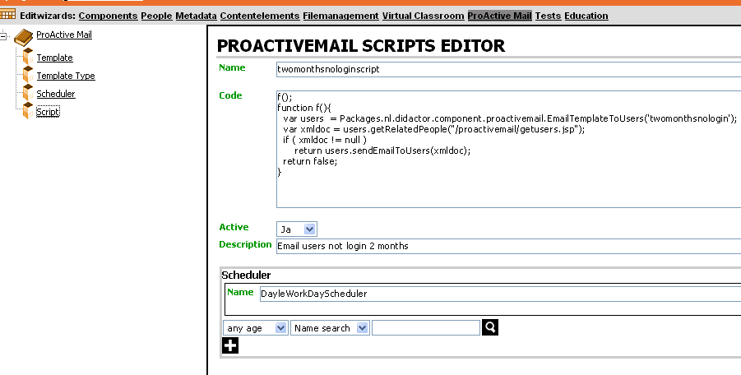
- Defining script template

Setting the name of the script, scheduler which will run the script at corresponding time and Active field are done as in previous steps, but to write a code for script system administrator need help of an programmer. We do effort to make this job quite easy for developers.
If we analyze a job script should do, it can be separate in next steps.

- collect the users defined in email context template;
- do filtering of users by some criteria;
- send emails to users.

      - Collect users

For first step, we write one java class EmailTemplateToUsers. Constructor of this class, declared as

public EmailTemplateToUsers(String templateName)

has one parameter, email template name, which should be set to the name of template for which we right this script.

Two useful methods of this class are:

public org.w3c.dom.Document getRelatedPeople(String url);
public boolean sendEmailToUsers(org.w3c.dom.Document d);

Method getRelatedPeople has one parameter, url, which is relative path to the jsp file, deployed on web server, let we called them getusers.jsp (this name is already used in emailing templates which is delivered as part of Pro-Active Mail component, so programmer should use different name for it), which will do all necessary logic to collect related users from database and to do necessary filtering of user to be emailed. We do more effort to do this job again easy for jsp developer, writing a jsp file named users.jsp, which do collecting of users, and which should be included as

<%@include file="users.jsp" %>

in getusers.jsp file. In this file, some useful variable are defined:

String jsp_subject; - contains subject field from email template
String jsp_body; - contains body from field email template
String jsp_from; - contains from field from email template
String jsp_datetime; - contains date field from email template

HashMap emailUsers; - contains users for emailing

emailUsers variable contains as key user number (mmbase number column in people table in Didactor database) and an array of objects as value. This array is declared as

Object[] o = {number,
firstname,
lastname,
username,
email,
lastactivity};

and contains string values, which is named in previous example as related columns in people table in Didactor database. Field which is collected from database can be seen and easy changed (deleting any of above field is not allowed and will bring an exception) are defined in the file getFields.jsp.

Doing this, first step is finished, and now should be done next step – filtering, in the same getusers.jsp file.

      - Filtering users

Now, the job of programmer is to filter these objects by some criteria need for this template type, which will usually need of him to do some database requests, and finally writing emailUsers as the XML in the jsp file.
What we really call filtering, will be explained now on an example.
Suppose we want to email all users from classA who didnot do login to Didactor for last two months. So, we will select in email context template, in field classes, classA. When script execute, it will first select all users from classA. Now, we must do filtering, which means to find all of these user who did not login for last two months, figure 8. This we call filtering.

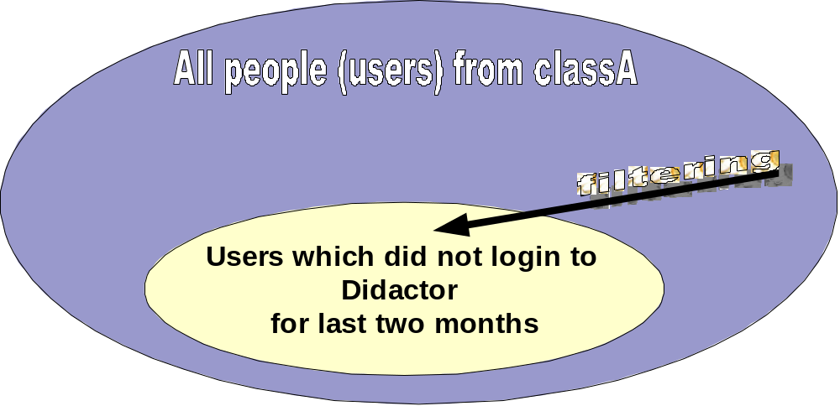

- Do filtering

The structure of XML output of web-request done by getRelatedPeople at location (url) given as method parameter, should be as follow:

<template>
<subject></subject>
<body></body>
<from></from>
<users>
<user>
<firstname></firstname>
<lastname></lastname>
<username></username>
<email></email>
[ OPTIONAL
<subject></subject>
<body></body>
<from></from>
]
</user>
...
...
...
</users>
</template>

Meaning of all tags are understandable from their name, and OPTIONAL values for subject, body and from, in the user tag, is for situation that these fields should be set on specific value in the email for this user.

      - Sending emails

After these, script continue executing, and now we can call method sendEmailToUsers, which receive as parameter document ( an instance of org.w3c.dom.Document ) returned from call of method getRelatedPeople, and do sending emails.

Testing new script
After do all of previous steps, system administrator and programmer should check functionality by running script manually. It can be done choosing menu item ‘ProActive Mail’ from menu in education bar of Didactor. Executing script can give success or no success message, and in the log file programmer can see all necessary information for easy debug the script.

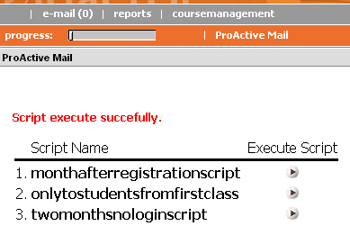
- Testing script

4 Permissions

Only the system administrator can do all of previous job. Teacher is allowed to change email context template, and only this option will be available to him, but before that system administrator should do some set in coursemanagament, People / Roles menu item, for Teacher role. rwd option for teacher column and proactivemail row should be set, figure 9.

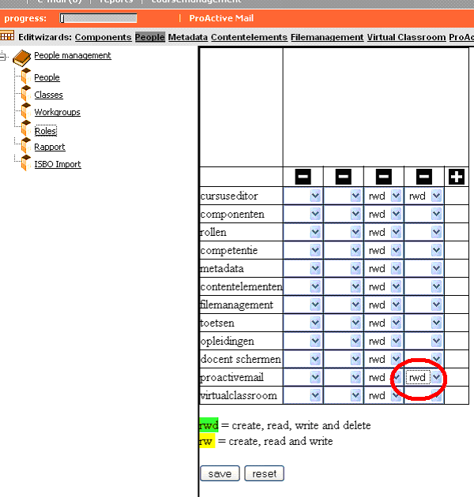
- Setting permission for teacher role

5 Delivered context

As part of the Didactor Pro-Active Mail component, two complete fully functional examples are delivered. First one is used for emailing the user one month after registration, and second one is for emailing the user who did not login to Didactor for 2 months.

The function of templates can be well recognized from their name.
In the folder proactivemail under the Didactor installation folder in the web server, can be found four files.
Function of user.jsp and getFields.jsp is described in section 3.3.4.a.
File getusers.jsp do the job of collecting users and filtering and is used for template type twomontsnologin.
File getusersmonthafterreg.jsp do the job of collecting users and filtering and is used for template type monthafterregistration.
  - Complete simple example

We will do now, step by step, one complete, the most simple, example.
Desired functionality is to send an email to some test user.
As prerequest, we should define one user (people), for testing purpose, and set his email account to some known address we can reach.

Let we first define template type and name it as “EmailOneUserAny5Minutes”, figure 11.

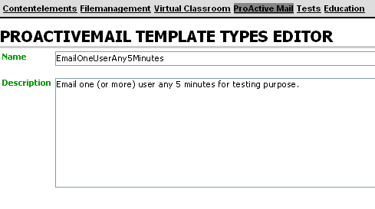
- Define template type

Now, let we define email context template, figure 12.

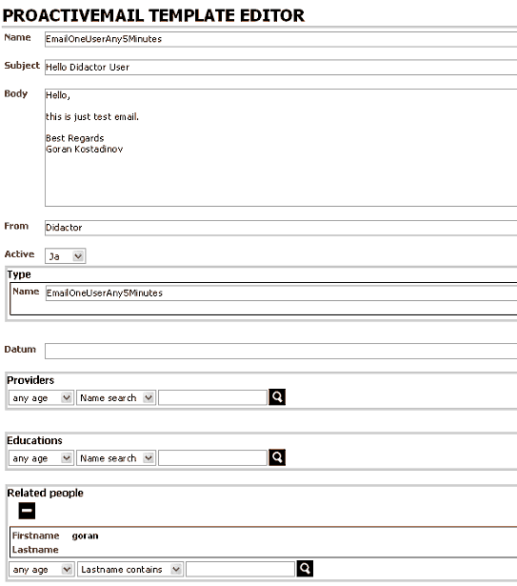
- Define email context template

Third step, let we define scheduler, figure 13. For now, make it inactive.

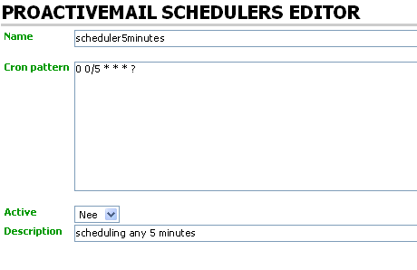
- Define scheduler

Fourth step, we will write one jsp page to collect the users, and named it “emailoneuserany5minutes.jsp”. Context of file is as follow:

<%@taglib uri="http://www.mmbase.org/mmbase-taglib-1.0" prefix="mm" %>
<%@taglib uri="http://www.didactor.nl/ditaglib_1.0" prefix="di" %>
<mm:content expires="0">
<% response.setContentType("text/xml"); %>
<%@page import = "java.lang.Integer" %>
<%@page import = "java.lang.String" %>
<%@page import = "java.util.Random" %>
<%@page import = "java.util.HashMap" %>
<%@page import = "java.util.ArrayList" %>
<%@page import = "java.util.Collection" %>
<%@page import = "java.util.Iterator" %>
<mm:cloud method="logout">
<mm:import externid="username" required="true" jspvar="username"/>
<mm:import externid="password" required="true" jspvar="password"/>
<mm:import externid="templatename" required="true" jspvar="templatename"/>
<mm:cloud username="$username" password="$password" jspvar="cloud" method="pagelogon">
<template>
<%
try {
%>

<%@include file="users.jsp" %>

<from><%=jsp_from%></from>
<subject><%=jsp_subject%></subject>
<body><%=jsp_body%></body>
<users>
<%
Iterator it1 = ((Collection)emailUsers.values()).iterator();
while ( it1.hasNext() ) {
Object[] o = (Object[])it1.next();
%>
<user>
<firstname><%=(String)o[1]%></firstname>
<lastname><%=(String)o[2]%></lastname>
<username><%=(String)o[3]%></username>
<email><%=(String)o[4]%></email>
<lastactivity><%=(String)o[5]%></lastactivity>
</user>
<%
}
%>
</users>
<%
} catch (Exception ex) {
%>
<error>
<% ex.toString(); %>
</error>
<%
}
%>
</template>
</mm:cloud>
</mm:cloud>
</mm:content>
Put this file in the didactor installation folder, under the folder proactivemail. Note that in this example we dont need to write any filtering of users, because all users we take from database by criteria defined in email context template, will be emailed.

Fifth, let we define script, figure 14, and make it active.

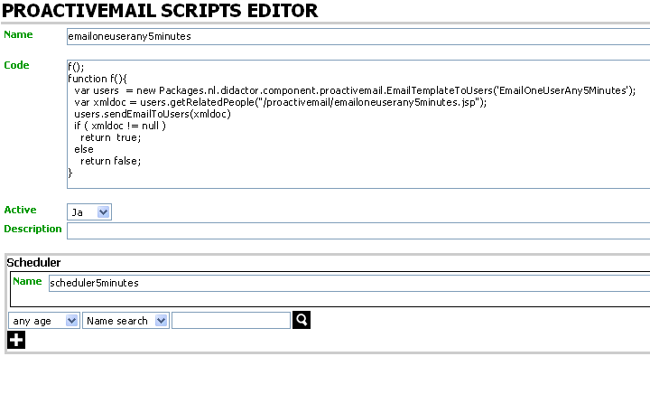
- Define scheduler

Now, let we test script, figure 15. If everything ok, we will receive an email on our test email account, and successfull message will be shown in testing script screen.
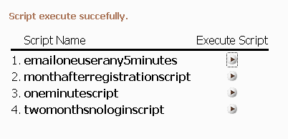
- Test script

Note that, for now, we test only quality of our script and settings of email context template, no the scheduler, becase we directly call executing of script, not via scheduler.

To test scheduler, let we make it active, figure 16., and wait 5-10 minutes for automatic sending email on our test email account. If everything is ok, we will receive email, if something wrong, go to mmbase.log file, see error, correct it and wait next 5 minutes for email receiving. Common error is that we do a syntax error in cron pattern field in scheduler template.
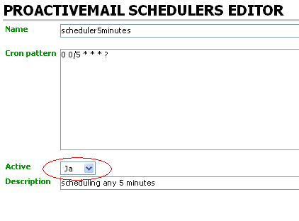
- Make scheduler active

